**CENG 103 LAB 3 1.11.2016**

**1) a)** Write program that writes the numbers starting from 1 to a number which is taking from the user.

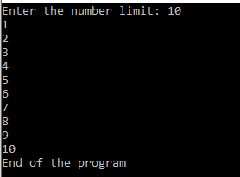

**b)** Write a program that shows power of a given number by user until the limit given by user.

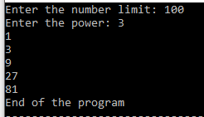

**2)** Write a program that calculates factorial given by user.

Example 4! = 4.3.2.1 = 24 , 6! = 6*5*4*3*2*1 = 720



**3)** Write a program that shows fibonacci number less then a number which enters by user.

